MC2 will contain two data files spanning the entire length of the simulation (12 am on April 6, 2020 to 11:59 pm on April 10, 2020), containing radiation measurements from mobile and static radiation sensors. MC2 also provides a set of supporting files (described below).

‘MobileSensorReadings.csv’ contains readings from 50 mobile sensors that are attached to cars. Data fields include: Timestamp, Sensor-id, Long, Lat, Value, Units, User-id. The timestamps are reported in 5 second intervals, though poor data connectivity can result in missing data. Each sensor has a unique identifier that is a number from 1 to 50. Location of the sensor is reported as longitude and latitude values (see map description below). The radiation measurement is provided in the Value field. Radiation is reported with units of counts per minute (cpm). Each measurement is independent and does not represent a summation over the previous minute. Some users have chosen to attach a user ID to their measurements while some others chose with a default name.

Be prepared for missing and corrupted data, skipped timesteps, and other issues. Both radiation measurements and movements may be affected by conditions in the city.

Supporting files:

The locations of the static sensors can be found in the file ‘StaticSensorLocations.csv’

Several maps have been provided as images, some with labels and some without.

A map of the neighborhoods has also been provided as a shapefile, which is contained in the folder ‘StHimarkNeighborhoodShapefile’. Geometry of the polygons is reported in meters.

If you wish to geolocate any of the image maps you may use these reference points:

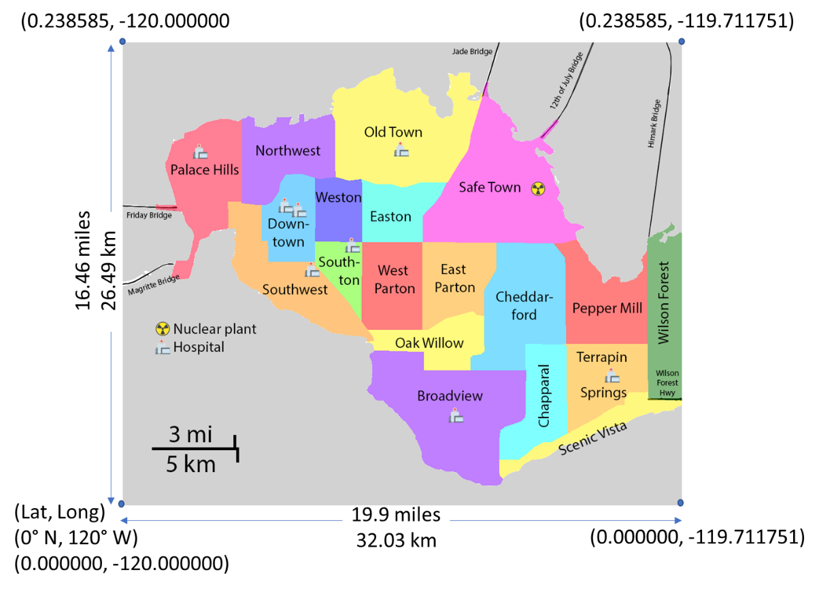

Hospitals are located at:

|  |  |
| --- | --- |
| Latitude | Longitude |
| 0.180960 | -119.959400 |
| 0.153120 | -119.915900 |
| 0.151090 | -119.909520 |
| 0.121800 | -119.904300 |
| 0.134560 | -119.883420 |
| 0.182990 | -119.855580 |
| 0.041470 | -119.828610 |
| 0.065250 | -119.744800 |

The Always Safe Nuclear plant is located at: (0.162679, -119.784825)